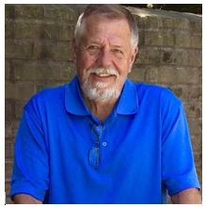
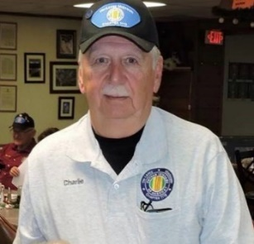

Charlie Riley & Dale Roland Memorial Golf Tournament

Fourth Annual Golf Tournament Fund Raiser

Saturday July 20, 2019
8:00 AM Shotgun Start
Holiday Hills Golf Club
Branson, MO

Registration Form

Name: ____________________________________ Phone Number: ____________________

Email Address: ________________________________________________________________

Address: ________________________________ State: _____ Zip: ________ Golf Fee: $ 75.00

Name: ____________________________________ Phone Number: ____________________

Email Address: ________________________________________________________________

Address: ________________________________ State: _____ Zip: ________ Golf Fee: $ 75.00

Name: ____________________________________ Phone Number: ____________________

Email Address: ________________________________________________________________

Address: ________________________________ State: _____ Zip: ________ Golf Fee: $ 75.00

Name: ____________________________________ Phone Number: ____________________

Email Address: ________________________________________________________________

Address: ________________________________ State: _____ Zip: ________ Golf Fee: $ 75.00

Please Mail Check(s) BEFORE July 10, 2019 to:
VVA-1119, P.O. Box 43, Kimberling City, MO 65686

We accept credit cards now: Call Dennis M. Strantz at (303) 525-1903

